**EX5 – BACKEND - INSTRUCTIONS**

A student has the following properties: an **ID**, a **NAME**, and a **SKILL**

|  |  |  |
| --- | --- | --- |
| Attributes | Type | Description |
| id | Integer | The ID of the student |
| name | String | The name of the student |
| favoriteSkill | String | The student favorite skill |

Our application can retrieve the student NAME or SKILL by providing his/her ID:

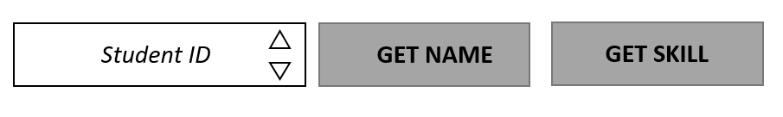

For example, if we have the following 2 students in our data:

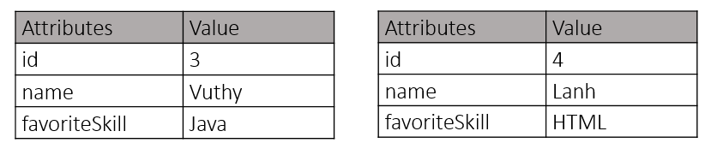

Then the GET NAME button will display VUTHY for ID = 3:

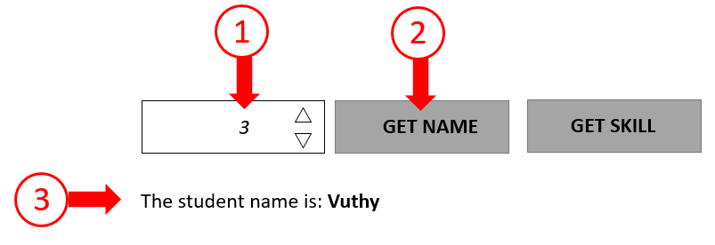

And the GET SKILL button will display HTML for ID = 4:

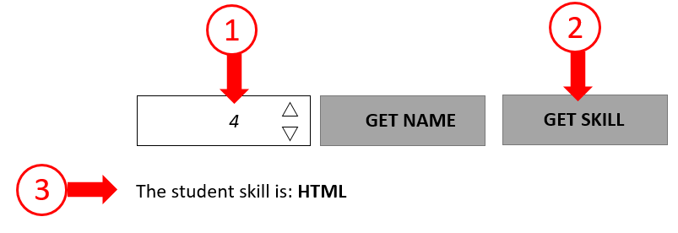

But for ID=5, we shall display: no student found:

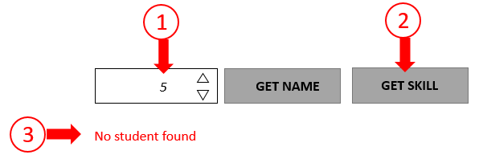

**EX5 – BACKEND - QUESTIONS**

*Note: the server will listen to the port: 3000*

**[SERVER SIDE]**

Q1 – Write a **STUDENT.JSON** file with the appropriate student data (create your own data).

Q2 – Complete SERVER.JS to read **STUDENT.JSON**

Q3 – Complete SERVER.JS to manage the following request:

GET <YOUR IP>:3000/student_name?id=<STUDENT ID>

This request shall return:

{"name": <the student name>} *if the student is found*

{"name": null} *if the student if not found*

Q4 – Complete SERVER.JS to manage the following request:

GET <YOUR IP>:3000/ student_skill? id=<STUDENT ID>

This request shall return:

{"skill": <the student favorite skill>} *if the student is found*

{" skill ": null} *if the student if not found*

**[CLIENT SIDE]**

Q5 – on STUDENTS.JS, link the button GET NAME and GET SKILL to the appropriate request and display the result on the P #message.

Note: if not student found, display: “no student found” (in red)

